**Chapter 2 - Matter**

**All Lectures Uploaded on YouTube:**

[**https://tinyurl.com/fkm10-chemistry**](https://tinyurl.com/fkm10-chemistry)



**2.1 Changes of States of Matter**

A change of state (also called phase transition) refers to the transformation of matter from one physical state to another such as solid, liquid, and gas without a change in temperature. These changes are explained by Kinetic Particle Theory and internal energy. Internal energy consists of kinetic energy (related to temperature) and potential energy (related to intermolecular forces). During a phase change, temperature remains constant because the energy supplied or released changes the potential energy of particles rather than their kinetic energy.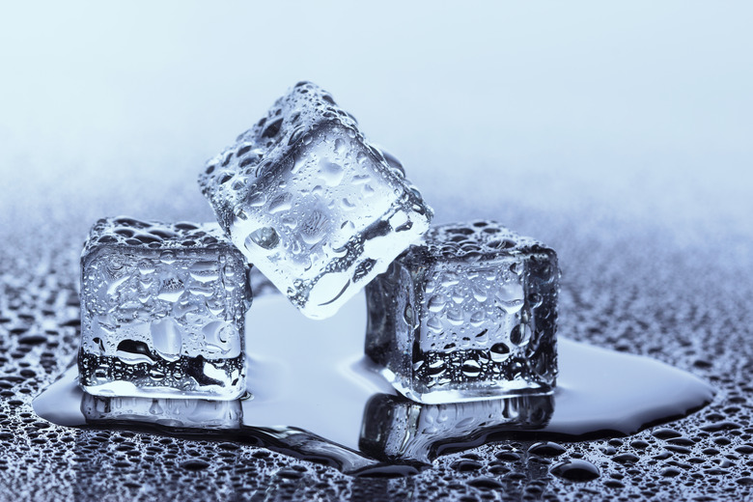

**Melting (Solid to Liquid)**

In a solid, particles are tightly packed in fixed positions and vibrate about their mean positions. When heat is supplied at the melting point, the particles absorb energy. This energy increases their potential energy, weakening the intermolecular forces that hold them in fixed positions. The kinetic energy does not increase, so the temperature remains constant. Once the forces are overcome, the solid melts and changes into a liquid where particles can move freely.

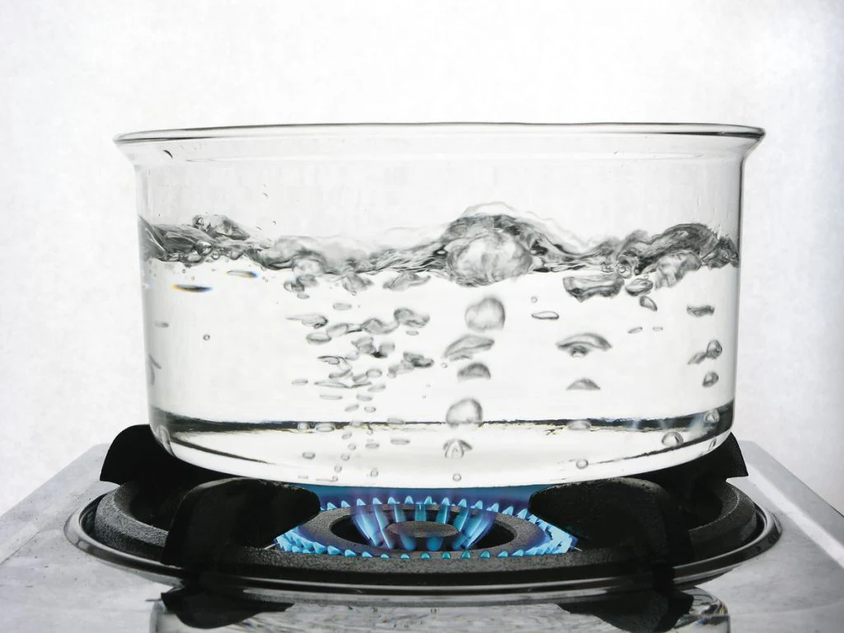

**Boiling (Liquid to Gas)**

In liquids, particles are close together but can slide past one another. When a liquid is heated to its boiling point, particles gain sufficient energy to overcome the attractive forces between them. The added energy increases potential energy, allowing particles to escape as gas. The temperature remains constant during boiling as energy is used for the phase change.



**Freezing (Liquid to Solid)**

Freezing occurs when a liquid loses energy. As energy is removed, particle motion slows and intermolecular forces pull the particles into fixed positions, forming a solid. Energy is released during freezing, reducing potential energy while temperature remains constant.

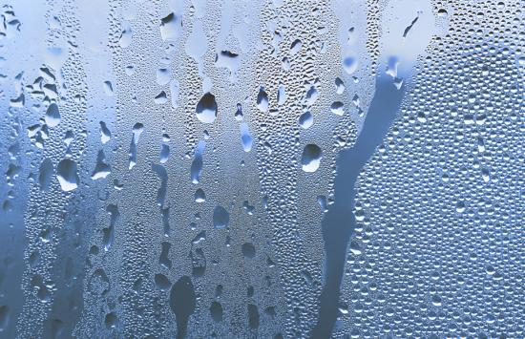

**Condensation (Gas to Liquid)**

Gas particles move rapidly and are far apart. When a gas loses energy, particle motion decreases and attractive forces pull particles closer together to form a liquid. Energy is released during condensation and the temperature remains constant.

**Sublimation (Solid to Gas)**

Sublimation is the direct conversion of a solid into a gas without passing through the liquid state. When particles gain enough energy, they overcome intermolecular forces and escape directly into the gaseous phase. Potential energy increases while temperature remains unchanged.

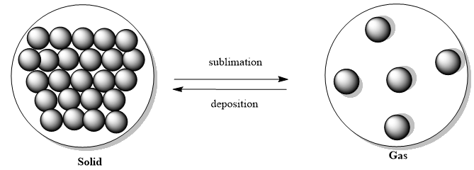

**Deposition (Gas to Solid)**

Deposition is the reverse of sublimation. Gas particles lose energy rapidly and directly form a solid without becoming liquid. Energy is released, potential energy decreases, and temperature remains constant.

**2.2 Heating and Cooling Curves**

Heating and cooling curves represent changes in temperature with time or energy during heating or cooling. They help explain phase changes using kinetic particle theory.

**2.2.1 Heating Curve**

**Solid Phase:**

As heat is supplied, the temperature of the solid increases. Kinetic energy increases and particles vibrate more vigorously.

**Melting:**

Temperature remains constant. Energy is absorbed as latent heat of fusion to overcome intermolecular forces.

**Liquid Phase:**

Temperature rises as particles gain kinetic energy and move faster.

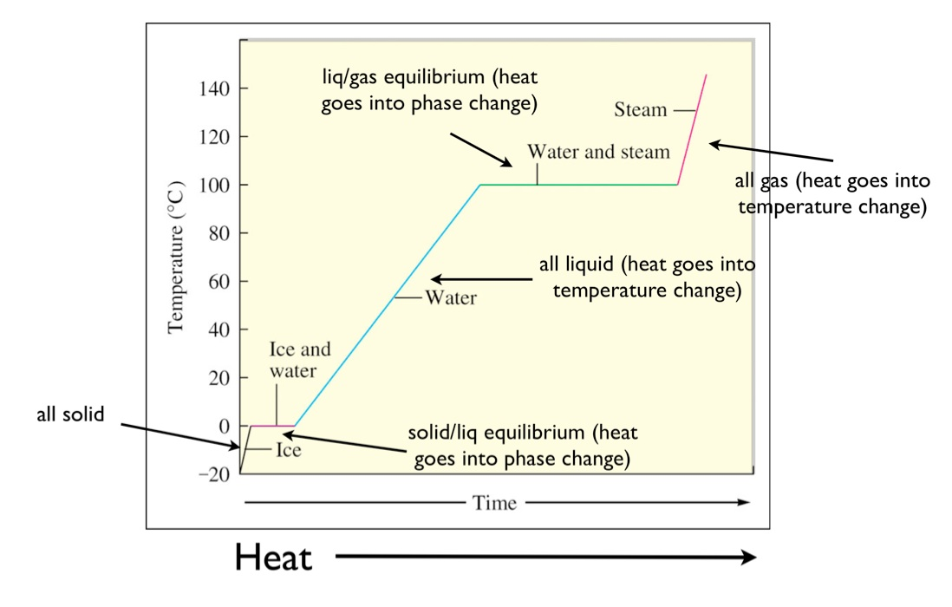

**Boiling:**

Temperature remains constant. Energy absorbed as latent heat of vaporization.

**Gas Phase:**

Temperature increases further as kinetic energy of gas particles increases.

**2.2.2 Cooling Curve**

**Gas Phase:**

Temperature decreases as kinetic energy decreases.

**Condensation:**

Temperature remains constant while latent heat is released.

**Liquid Phase:**

Temperature decreases as particles lose kinetic energy.

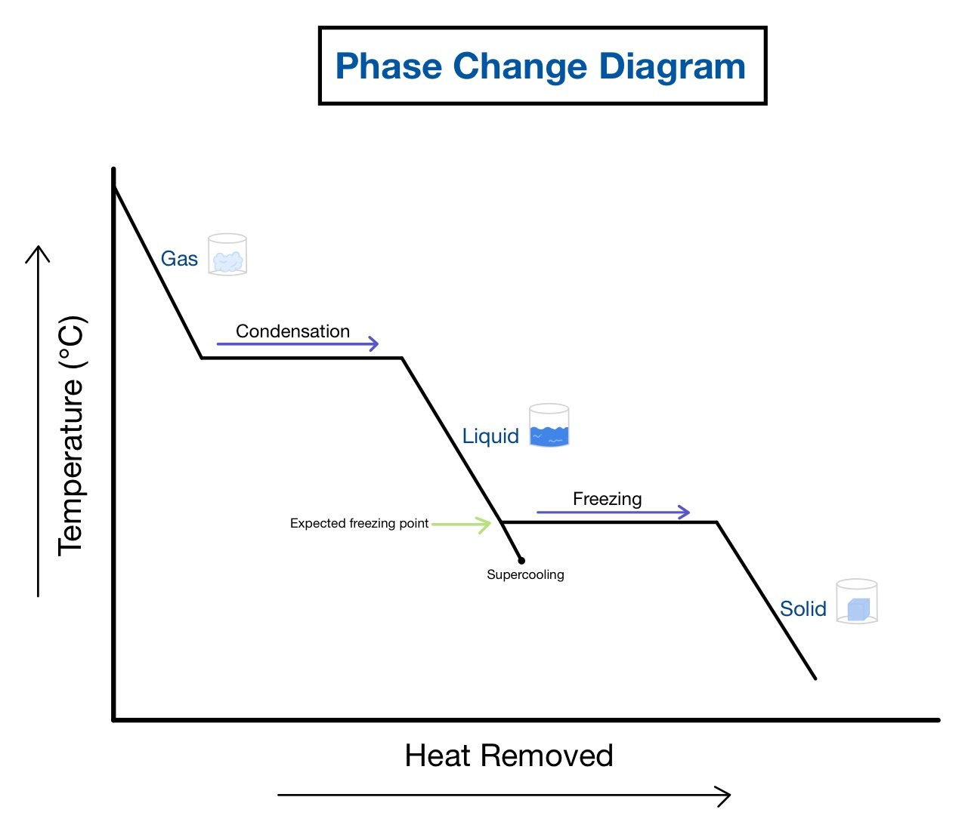

**Freezing:**

Temperature remains constant as latent heat of fusion is released.

**Solid Phase:**

Temperature decreases further as particles vibrate less.

**2.2.3 Kinetic Theory Interpretation**

**Kinetic Energy and Temperature:**

In the regions where the temperature is changing, the kinetic energy and potential energy increase.

**Potential Energy and Phase Changes:**

During flat regions of the curve, energy changes potential energy by breaking or forming intermolecular forces while kinetic energy remains constant.

**2.3 Evaporation and Boiling**

Evaporation is a surface phenomenon that occurs at any temperature below boiling point. High-energy molecules escape, causing cooling. Boiling occurs throughout the liquid at a fixed temperature with bubble formation.

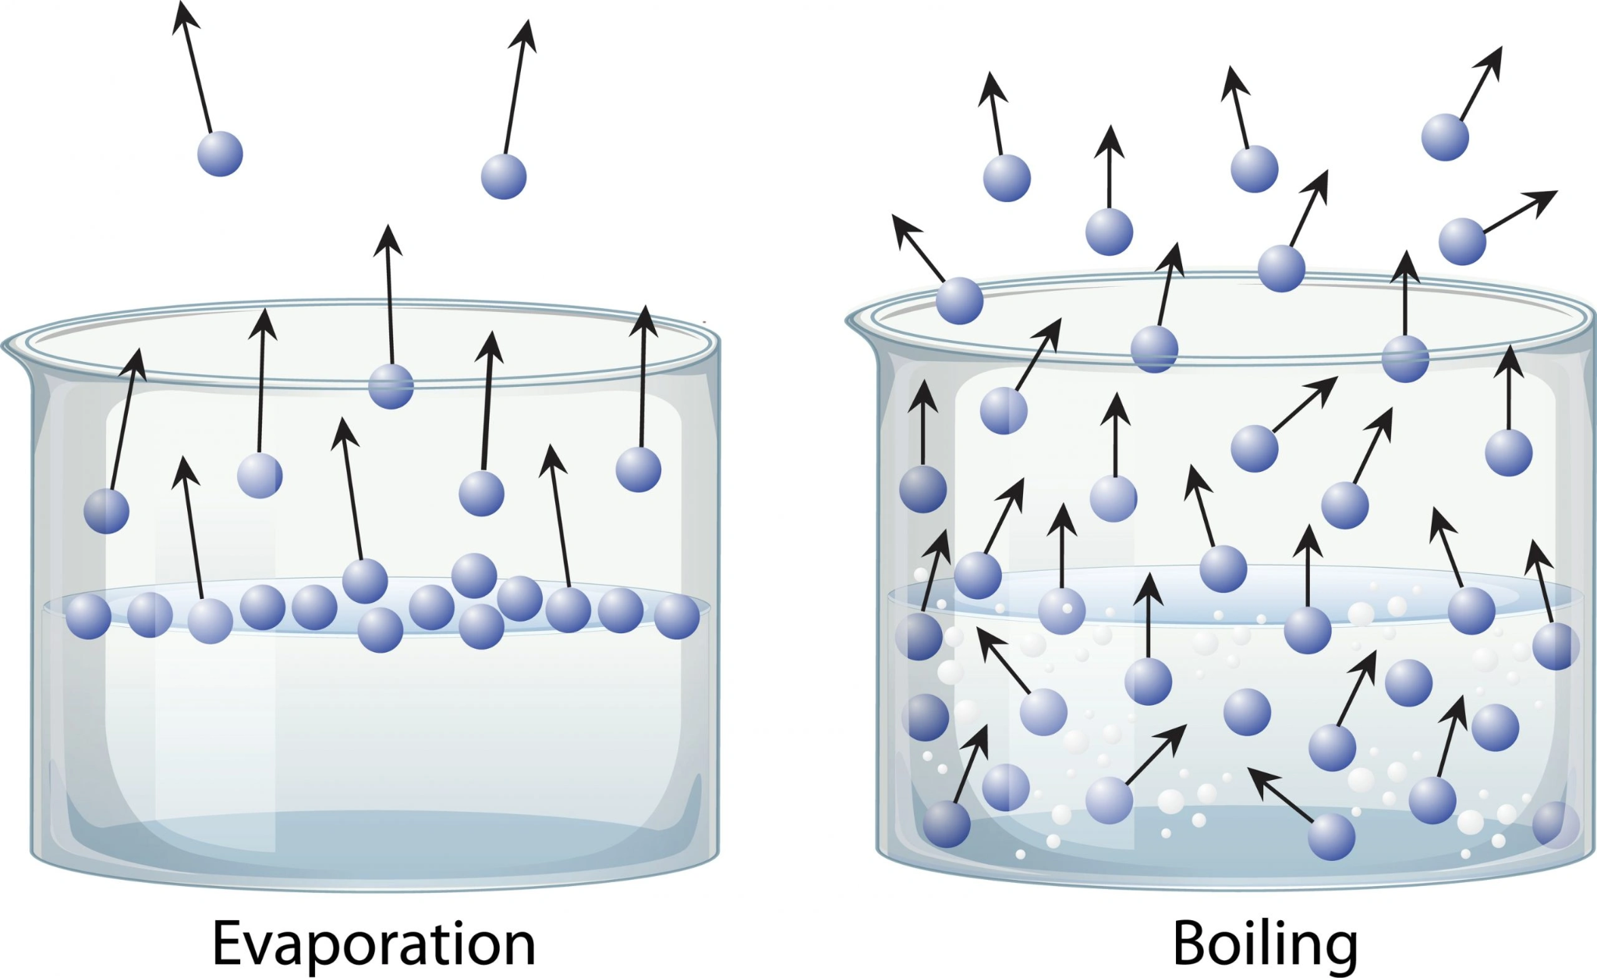

**2.3.1 Effect of Pressure on Evaporation and Boiling**

The effect of pressure on evaporation and boiling is primarily related to how it influences the rate at which molecules escape from the liquid's surface into the gas phase.

**Effect of Lower Pressure:**

At lower atmospheric pressures, the rate of evaporation increases. This is because there is less external pressure exerted on the liquid surface, making it easier for molecules to escape into the vapor phase.

Lower pressure reduces the boiling point of a liquid, which means the liquid can transition to the gas phase at a lower temperature. This indirectly affects evaporation by facilitating the conditions under which it can occur more readily.

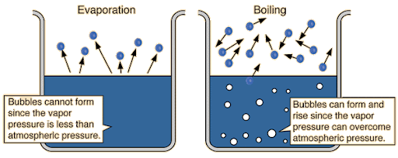

**Effect of Higher Pressure:**

At higher atmospheric pressures, the rate of evaporation decreases. The increased external pressure on the liquid surface makes it more difficult for molecules to escape into the vapour phase.

Higher pressure increases the boiling point of a liquid, which means the liquid requires a higher temperature to transition into the gas phase. This indirectly affects evaporation by making the conditions less favorable for it to occur.

**2.4 Kinetic Particle Theory and Gas Laws**

Gas behavior depends on pressure, volume, temperature, and number of moles.

**2.4.1 Boyle’s Law**

At constant temperature, pressure is inversely proportional to volume.

When the volume of a gas decreases, the gas particles have less space to move around. This results in more frequent collisions with the walls of the container, thereby increasing the pressure. Conversely, if the volume increases, the particles collide with the walls less often, decreasing the pressure.

**Constant Temperature:** The average kinetic energy of the particles remains constant since the temperature does not change. The speed of the particles does not change, but the frequency of collisions with the container walls changes due to the volume change.

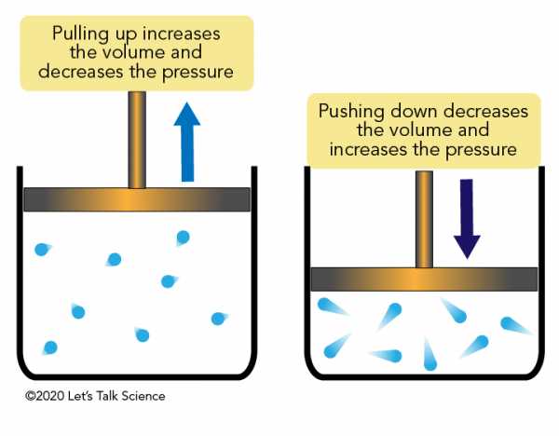

**2.4.2 Charles’s Law**

At constant pressure, volume is directly proportional to absolute temperature.

When the temperature of a gas increases, the kinetic energy of the gas particles increases. This means the particles move faster. To maintain constant pressure, the volume of the container must increase to allow the particles to travel further between collisions with the container walls, thus keeping the pressure constant.

**Constant Pressure:** The volume changes to balance the increased or decreased frequency and force of collisions due to temperature changes, maintaining constant pressure.

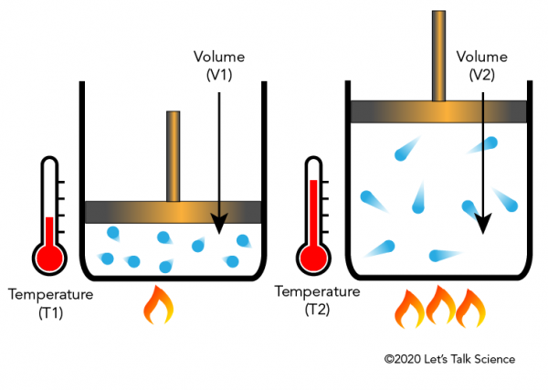

**2.4.3 Avogadro’s Law**

At constant temperature and pressure, volume is directly proportional to the number of moles.

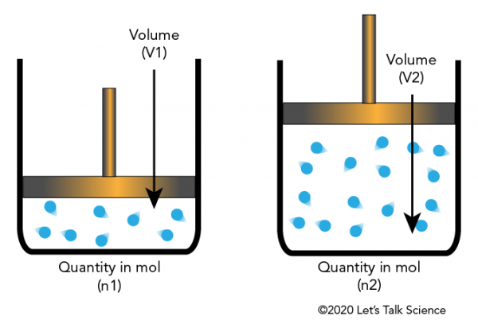

When the number of gas particles (moles) increases, there are more particles colliding with the walls of the container. To keep the pressure constant, the volume of the container must increase to accommodate the additional particles and maintain the same number of collisions per unit area.

**Constant Temperature and Pressure:** The temperature ensures the kinetic energy of each particle remains the same, and the pressure remains constant by adjusting the volume according to the number of particles.

**2.5 Diffusion of Gases**

Diffusion is the spreading of gas particles due to random motion. One of the simplest examples of diffusion in everyday use is when perfume is sprayed and dispersed across a room. At first, perfume molecules are concentrated in the sprayer and dispersed across the room.

**2.5.1 Diffusion Process Explained by Kinetic Particle Theory**

Gas particles move randomly and collide, causing uniform mixing.

When two different gases come into contact, their particles begin to move together. Because of their kinetic energy, each type of a gas particle moves randomly in all directions. The random motion of these particles ensures that the particles from each of the two gases move into the other gas's space.

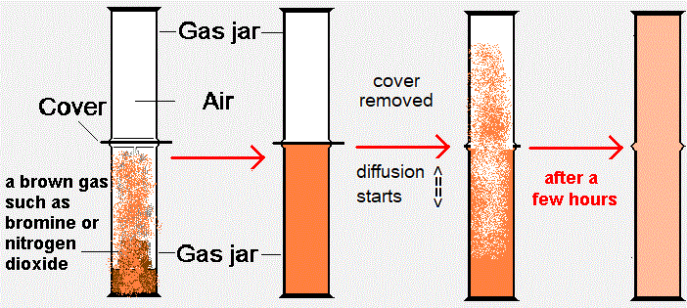

**2.5.2 Factors Affecting Diffusion**

**Molecular Weight:**

Lighter gases diffuse faster.

**Temperature:**

Higher temperature increases diffusion rate.

**2.6 Sublimation**

Sublimation occurs when solids with weak intermolecular forces change directly into gas.

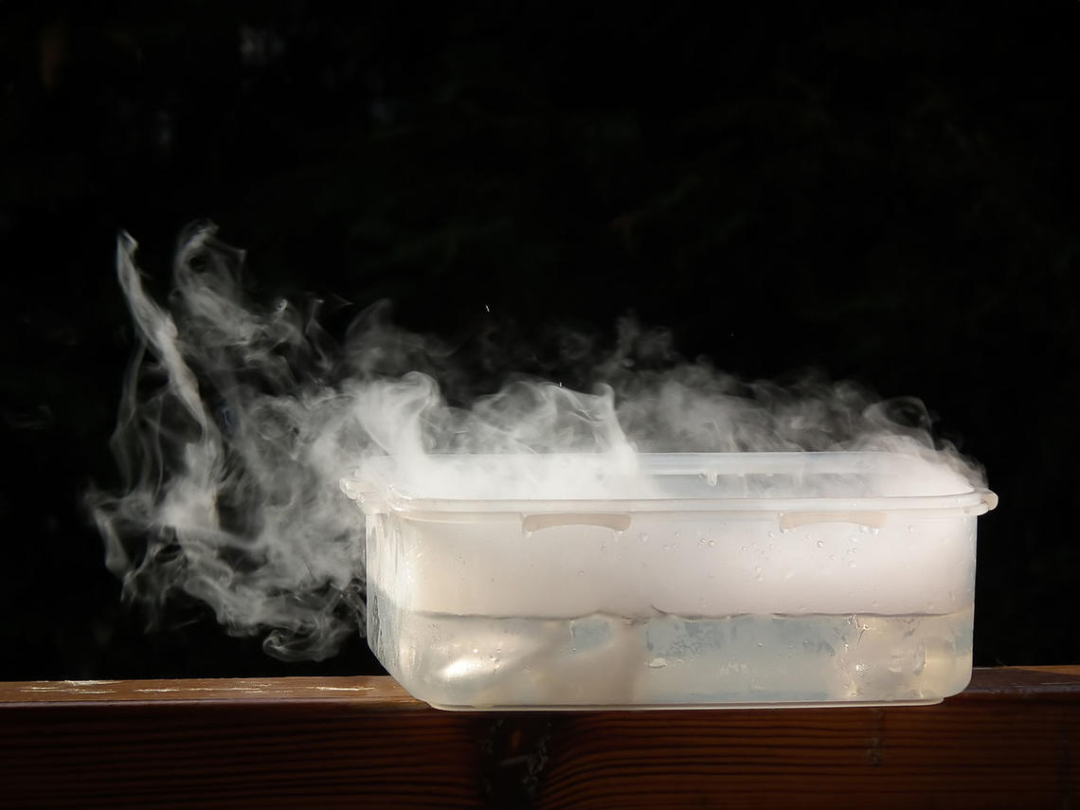

**Application Of Sublimation In Our Life:**

* The solid air fresheners we often use in our cars and homes rely solely on the magic of sublimation. The solid fragrance within slowly transforms into a delightful vapour, filling the entire space with an enticing aroma that lingers in the air.
* In the textile industry 3D printing uses a sublimation process. Dye sublimation printers are now widely used for the printing process for a reduced cost. Dye sublimation is used to print a variety of objects such as T-shirts, pens, coffee mugs, and bags.
* In the food industry, freeze-drying food items for preservation for a longer duration is due to the process of sublimation.

**2.6.1 Importance of Diffusion Rates in Medicine**

When you take a drug, whether it’s taken by mouth or injected, it needs to diffuse from the injection site into your bloodstream. The diffusion rate determines how quickly a drug reaches its target area in your body.

Ultimately, diffusion determines how fast drugs spread in the body. Faster diffusion leads to quicker drug action.

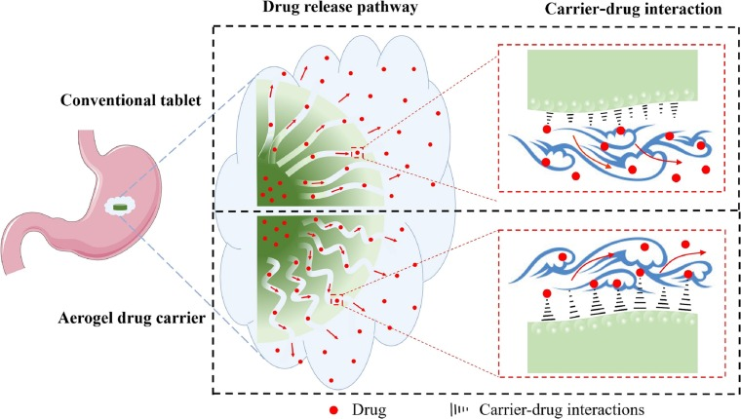

The rate of diffusion also depends on the composition of the drug (e.g. liquid, gel, tablet). Generally, liquid drugs move more quickly than solid drugs, as their particles have already dispersed.



